Call of Nature

By Oliver Bitar



# Introduction

The main purpose of our project is to make Lebanon a GREENER place, as we love the beauty of our country and are vastly heartbroken by the way it is getting polluted. So this is why we created our NGO which is named Call Of Nature. So basically in this app, we as the NGO will provide the user with next events that our NGO will conduct (such as cleaning a certain beach at a certain location for example) , It will also allow the user to become a volunteer, to add an area that is affected, and to donate. The user also has the privilege to check the fresh news on environmental advancements.

# Background

We selected this project because we feel like many people are willing to contribute in making Lebanon a better place in terms of environment, but can’t find a certain platform to follow, and what better way to do that than with an NGO application that will guide the user to events. The design of the application was highlighted through its purpose, which a lot of the color green was used in order to make the user feel in a natural environment.

# Activities

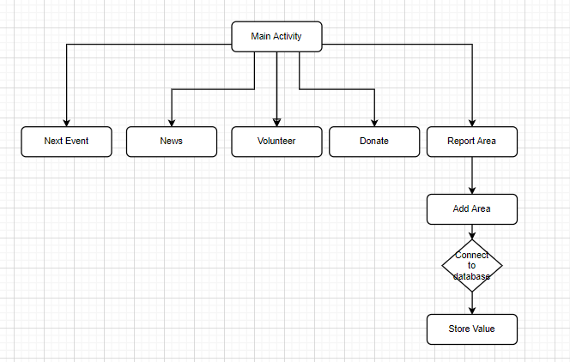

# a- Main Activity

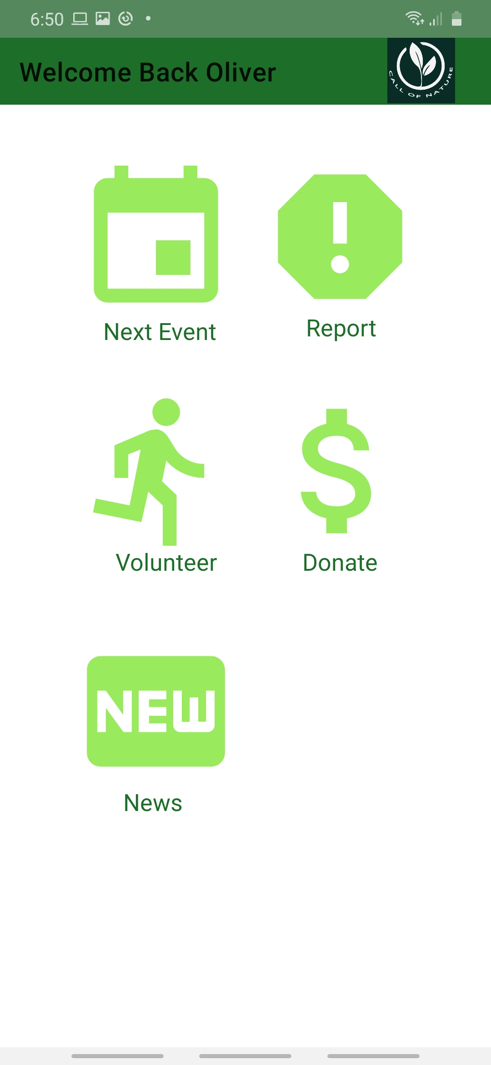

This is the main activity of our project, where we have links to five

Different activities. There is no need in explaining the code of it since it

Was covered in the demo.

## C:\Users\user\Downloads\WhatsApp Image 2020-12-15 at 6.54.09 AM (9).jpegb- New Event

This is the map that shows the next events that will soon occur.

For example, there is a beach clean-up in Kaslik on Saturday

8:00 am, which is the date of our COE exam. This is done by getting the

API Key from our google account and putting it in the Manifest

Folder, and the code implementation is explained in the demo

## c- Donate Page

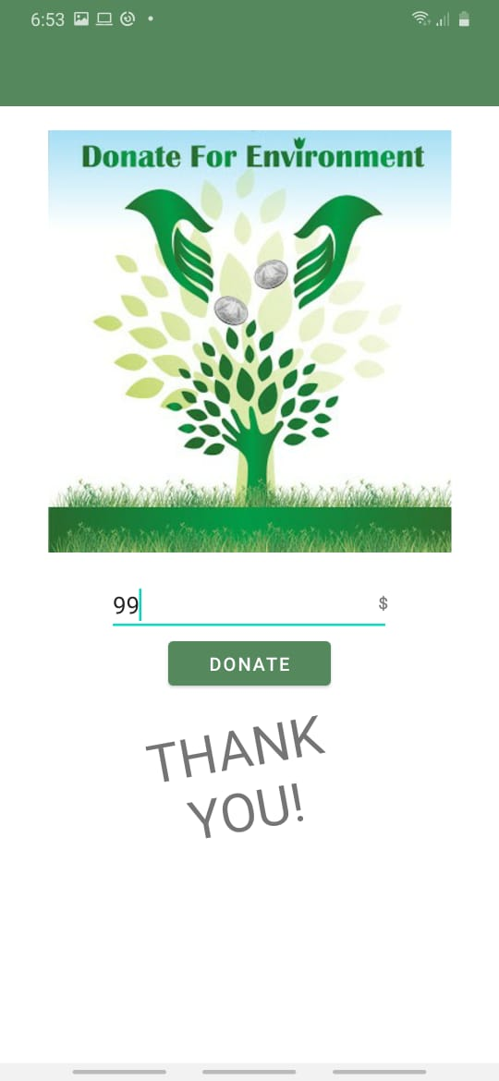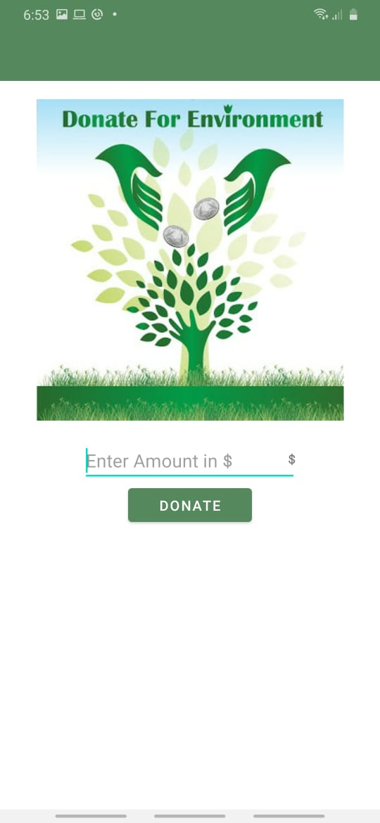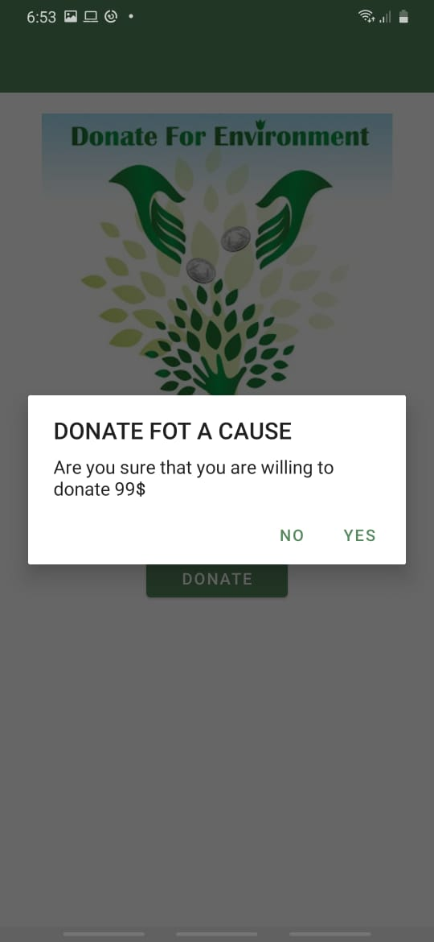

In this activity, the user can donate to the NGO and help with the fight against pollution, because the funds are directly going to the cause of fighting pollution. Now this activity has the alert dialogue and animation which are special, both of which are explained in the demo.

## d- News page

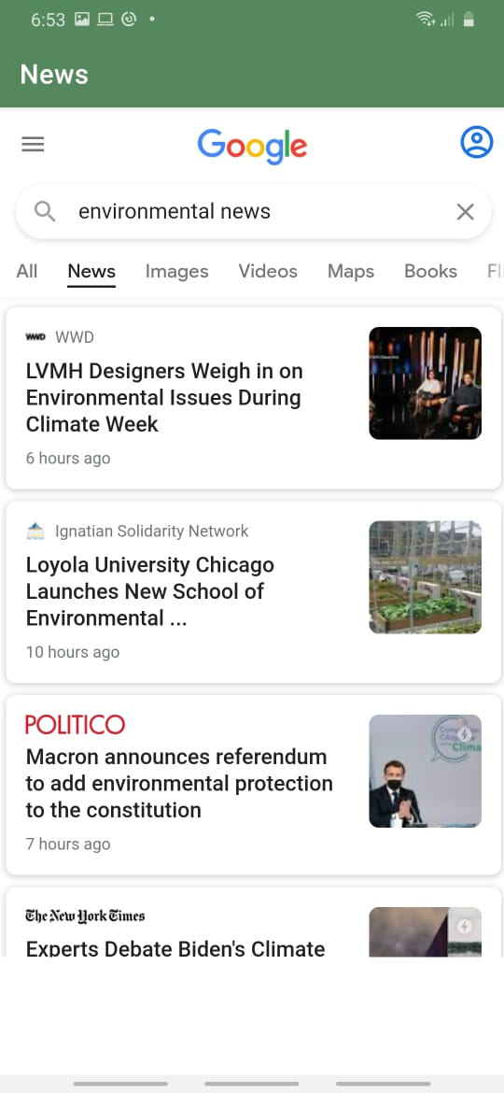

in this page the user can be updated on anything

new happening in the environmental news, and

any advancements on updates that a user who loves

the environment would enjoy.

## e- Volunteer page

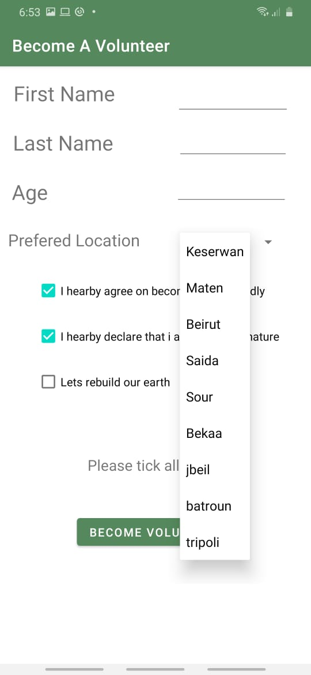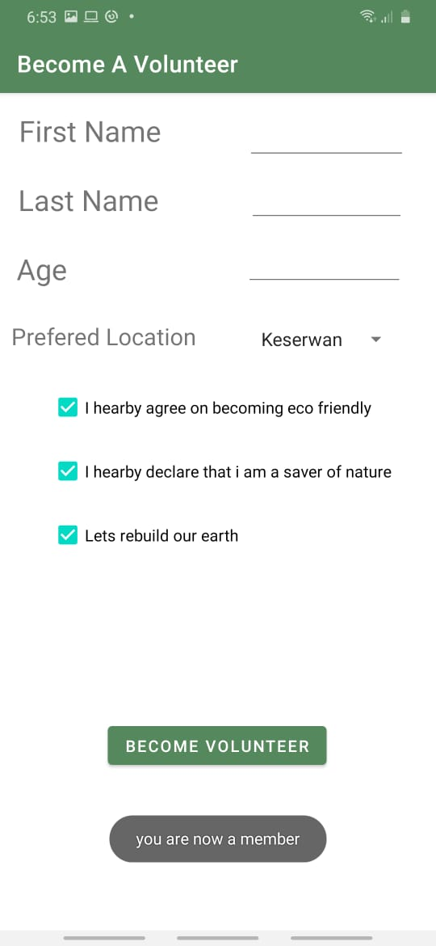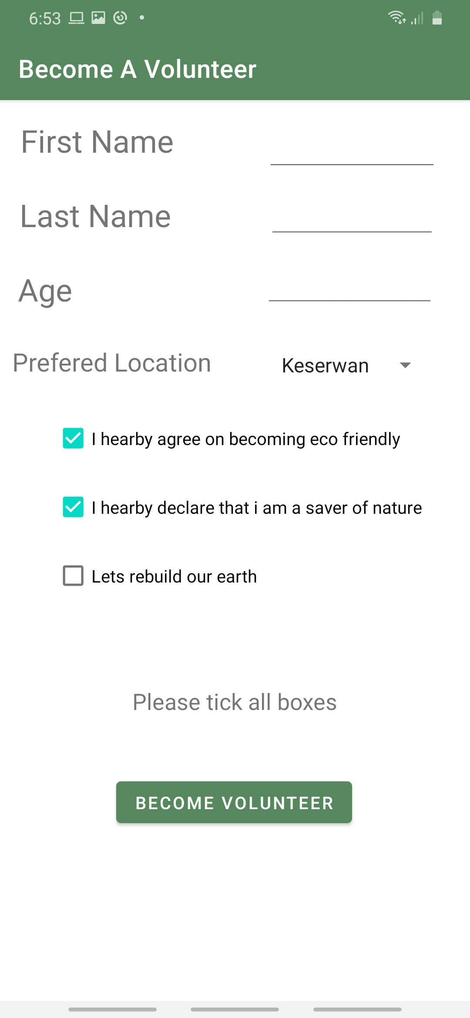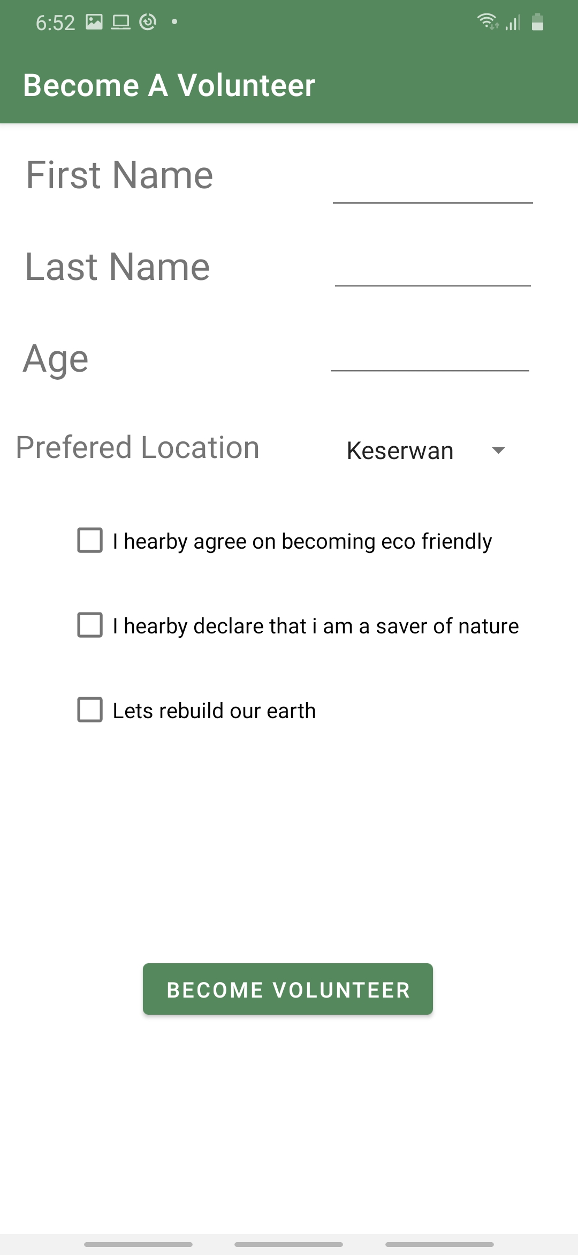

This activity is where the user can become a volunteer. This activity contains special UIs such as a spinner, a Toast and a shared preference where the shared preference will take the value of the name of the user and will put it in the main activity in the tool bar. Everything else is explained in the demo.

## f- Report Area

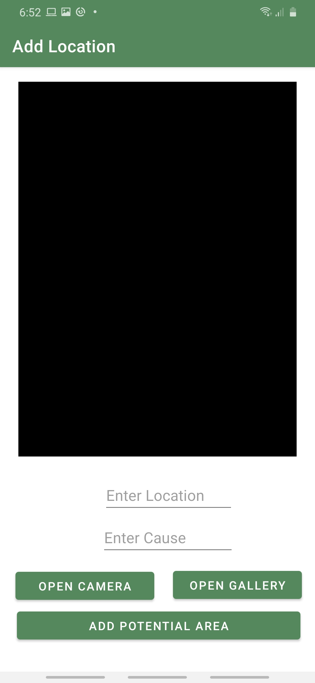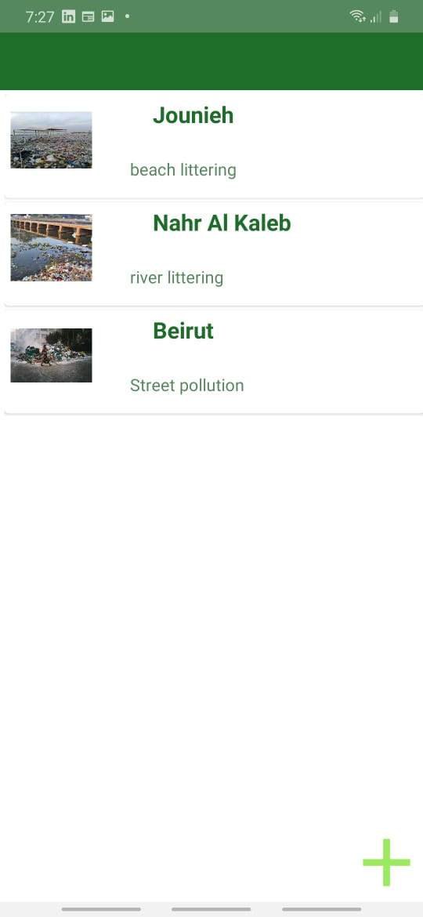

This is the part where the user is walking down the road and he sees a huge pile of trash of a polluted lake, and instead of just walking away, you can actually report it to us, where we will analyze it and perhaps put it as a next event for volunteers to join and clean.

The pic on the left was done by a recycler view made out of multiple card views, all of them are explained in the demo in detail (The adapter of the recycler view, the card view xml, and the class for the places).

The pic on the right shows how the user will report an area: he can access the camera or open the gallery, and add it as a potential area where it will be deployed to the pic on the left inside the recycler view. The info will also be added to the firebase database where the output will be shown below.

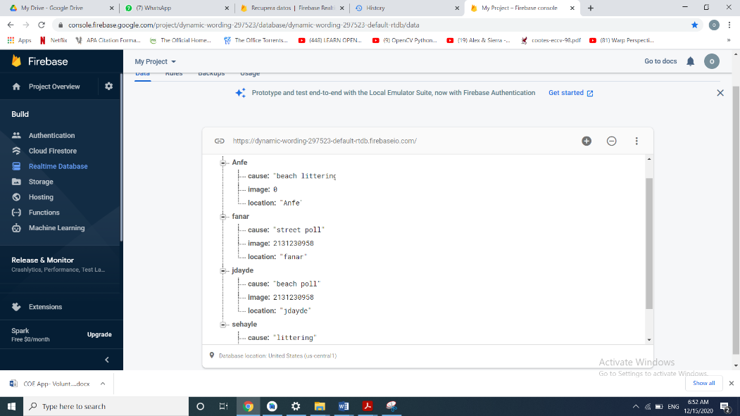

Everything regarding the database was fully detailed in the demo.

# UIs used:

* Text View
* Edit Text
* Buttons
* Spinners
* Check Box
* Recycler View
* Card View
* Image View
* Web View
* mapFragment
* Scroll View
* Toast
* Alert Diagram

# Other extras: Added sounds- Added animations- used fragments- used more complicated UI- taking picture with camera or gallery- persisting data with SQLite- Incorporating external APIs